

MARMARA UNIVERSITY
FACULTY OF ENGINEERING

PHYS 1104
PHYSICS LABORATORY II
—————————————————————————————————————————
Non-Ohmic Device in a Circuit
—————————————————————————————————————————
Section: 14

Group: 12

Instructure: Hüseyin YALTIRIK Date: 05/04/2025 05:30 pm

 | Department | Student ID Number | Name & Surname
1 | Computer Engineering | 150123073 | Emir GUDER
2 | Computer Engineering | 150123034 | Samet KURUS
3 | Computer Engineering | 150123046 | Cihangir YAMAN

Contents

1. Table of Contents
1. Table of Contents 2
2. Purpose 3
3. Theory 3
4. Experimental Setup 4
4.1.Procedure 4
5. Calculation and Results 6
6.Fitline 10
7. Discussion and Conclusion 12
8. References 13
9. Appendix 14
9.1. Source Code 14
9.2. Experiment Sheet 15

Purpose
To investigate and compare the non-ohmic behavior of a tungsten filament bulb with a
resistor which has ohmic characteristic. The purpose of this experiment is to investigate the non-ohmic behaviour of a tungsten filament bulb in comparison with an ohmic resistor. According to Ohm's Law, the current flowing through ideal resistors has a linear relationship with the applied voltage, but some circuit elements such as tungsten filament bulbs do not obey this rule and show a non-linear current-voltage characteristic. In this experiment, the current-voltage values of both circuit elements will be measured and compared graphically and the temperature dependent resistance change of the bulb will be observed.
Theory
According to the Ohm’s law, the resistance of a resistor varies linearly as the voltage
applied on it increases. This is called as Ohmic behavior and ohmic devices create a
straight line on a current versus potential difference (voltage) plot. Since a bulb made with the tungsten filament has a resistance dependence on the temperature, the plot of current versus voltage will be like a parabola for the bulb.
Here, the reason of the nonlinear resistance change is arisen from the scattering mechanism in metals which hinders the electron transport.
As a result, the resistance of the device increases. Due to the tungsten metal has a large temperature coefficient, the resistance of the filament bulb increases as the filament heats up. If the voltage applied on the bulb increases, the temperature and the brightness of the bulb also
increases. Below, the resistance formula is given related to the temperature. Using this formula, one can find the resistance of the bulb at corresponding temperature.

𝑅𝑏𝑢𝑙𝑏 = 𝑅𝑟𝑜𝑜𝑚[1 + 𝛼(𝑇 ― 𝑇𝑟𝑜𝑜𝑚)]

Here, the α is the temperature coefficient of the tungsten and T is the temperature in Kelvin for the maximum terminal voltage you apply. 𝑇𝑟𝑜𝑜𝑚 is 293 K. 𝑅𝑟𝑜𝑜𝑚 is the resistance of the bulb at the room temperature before starting the experiment. 𝑅 is the resistance at maximum terminal voltage.
Experimental Setup
1. Resistor (value between 10Ω-20Ω) x1
2. Digital Multimeter x2
3. Filament Bulb (2.5V – 0.3A) x1
4. DC Voltage Source (0 – 30 V range) x1
5. Connection cables

Procedure:
First, the maximum voltage of the voltmeter is measured. This voltage is divided by 15 to find the amount of voltage increase at the end of each measurement.Starting from 0, it is increased up to the maximum voltage value. Then the same process is done by decreasing from maximum to 0. In a circuit where a resistor and a bulb are connected in series, the ammeter is connected in series to these 2 resistors. Voltmeters are connected in parallel to both. After the circuit is set up, it is necessary to make measurements one by one and fill the table. Current and volt values are written to the table and the change of the bulb is observed.

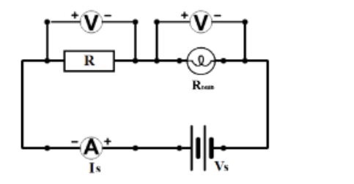
Filament Bulb Circuit

In this experiment, a circuit was constructed to observe the non-ohmic behaviour of a tungsten filament bulb. The steps performed are listed below:
The circuit was constructed as shown in Figure.A resistor (rheostat) was added in series with the bulb.
Before starting the experiment, the resistance of the bulb at room temperature (293 K) was measured with a multimeter.
Considering the temperature coefficient and melting point of tungsten, the maximum resistance value that the bulb can reach was calculated using the Equation given in Theory.
The maximum voltage value of the power supply was divided into 15 equal steps and the amount of voltage increase was calculated.
Throughout the experiment, the output voltage of the power supply was increased by the determined step value, reaching the maximum value, and then decreased again to zero voltage with the same steps.

Calculations:

We measure the resistance, voltage and current flow through each element of the circuit and we reach the values in the Table 1 below.

Table 1: Voltage and Current values of the Circuit
 |  | Voltage
# | Power Source (V_{s}) | Bulb (V_{b}) | Resistor (V_{r}) | Current (A)
1 | 0.5 | 0.025 | 0.465 | 0.03
2 | 1.0 | 0.051 | 0.934 | 0.06
3 | 1.5 | 0.080 | 1.400 | 0.08
4 | 2.0 | 0.120 | 1.850 | 0.11
5 | 2.5 | 0.190 | 2.250 | 0.14
6 | 3.0 | 0.393 | 2.570 | 0.16
7 | 3.5 | 0.630 | 2.820 | 0.17
8 | 4.0 | 0.850 | 3.100 | 0.19
9 | 4.5 | 1.070 | 3.400 | 0.21
10 | 5.0 | 1.300 | 3.600 | 0.23
11 | 5.5 | 1.510 | 3.940 | 0.24
12 | 6.0 | 1.750 | 4.200 | 0.26
13 | 6.5 | 1.980 | 4.450 | 0.27
14 | 7.0 | 2.200 | 4.700 | 0.29
15 | 7.2 | 2.310 | 4.800 | 0.30
16 | 7.0 | 2.210 | 4.720 | 0.29
17 | 6.5 | 1.980 | 4.460 | 0.27
18 | 6.0 | 1.740 | 4.200 | 0.26
19 | 5.5 | 1.510 | 3.940 | 0.24
20 | 5.0 | 1.280 | 3.660 | 0.23
21 | 4.5 | 1.120 | 3.380 | 0.21
22 | 4.0 | 0.860 | 3.100 | 0.19
23 | 3.5 | 0.650 | 2.810 | 0.17
24 | 3.0 | 0.430 | 2.540 | 0.16
25 | 2.5 | 0.230 | 2.230 | 0.14
26 | 2.0 | 0.140 | 1.830 | 0.11
27 | 1.5 | 0.090 | 1.380 | 0.08
28 | 1.0 | 0.050 | 0.920 | 0.06
29 | 0.5 | 0.025 | 0.460 | 0.03

In this experiment we see the relation between current and voltage is non-linear. Actually, according to Ohm’s Law (Equation 1) the relation between current and voltage must be proportionally linear.
V = IR (1)

However, in reality the relation is non-linear because of the fact that resistance of the non-ohmic devices such as our bulb increasing according to temperature. Therefore, the resistance of the bulb increases with current flows through it and the plot on the Graph 1 get steeper

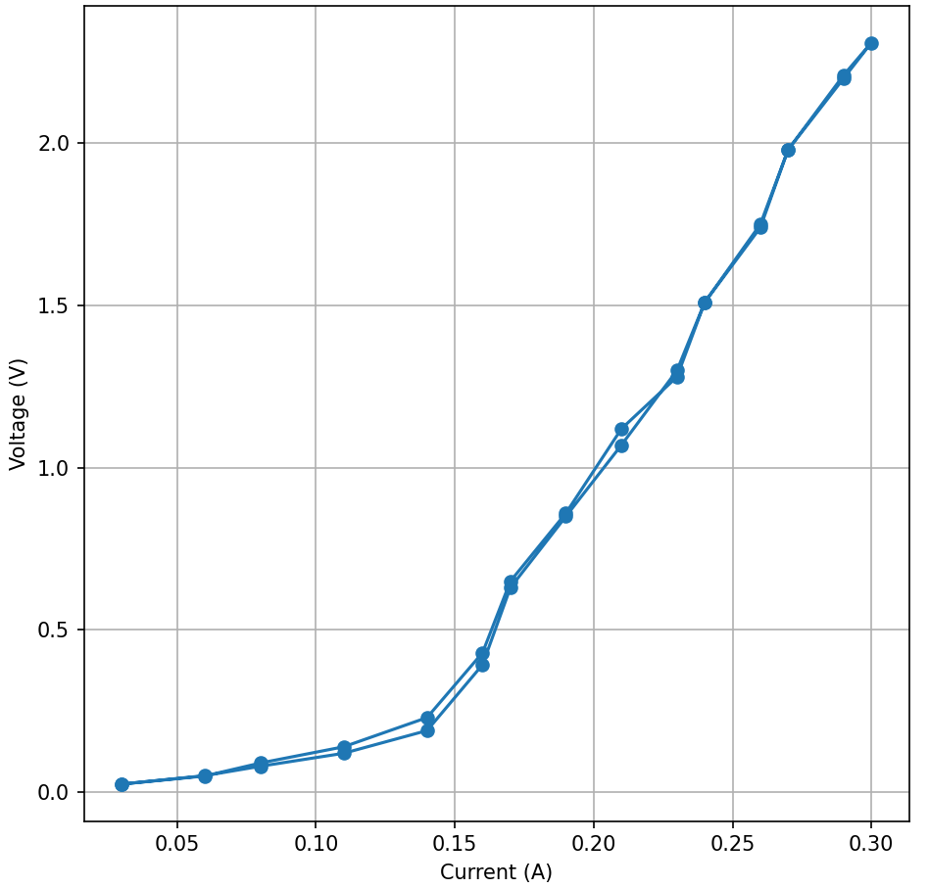Graph 1: Current (A) - Voltage (V) of the Bulb

On the other hand, in ohmic devices such as our resistor, the voltage – current graph is linear and never get steeper like graph of non-ohmic devices. Because, Ohm’s Law (Equation 1) is valid for the ohmic devices. We can see the graph of voltage – current graph of resistor in the Graph 2 below. We can reach that resistance does not change with the temperature in the ohmic devices.

Graph 2: Current (A) - Voltage (V) of the Resistor

Fit-Line Graphs;
To better understand behaviors of the ohmic and non-ohmic devices in our experiment, we applied curve fitting to the experimental current and voltage data.

Tungsten Filament Bulb
The bulb showed a nonlinear current-voltage relationship. When the chart is created with data gained in experiment, the line formed a curve that deviated clearly from a straight line. This is also shows us that Ohm's Law does not hold for this component of the circuit.
I = aV² + bV + c
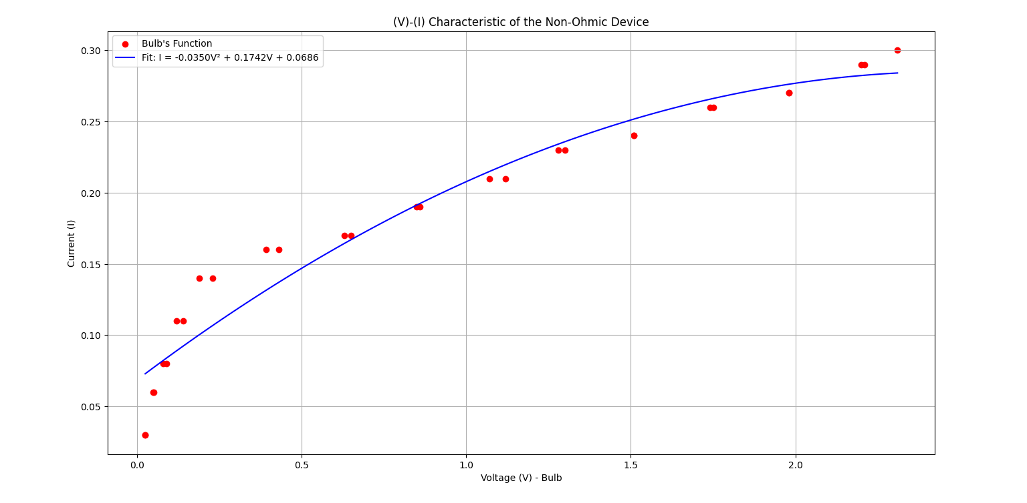

I =−0.0350V²+0.1742V+0.0686
This quadratic equation shows the non-linear and non-ohmic behavior. The negative coefficient for 𝑉² reflects the decreasing rate of current increase as voltage rises. This fit provides a clear mathematical model to describe the bulb's thermal resistance effects.

Rheostat (Ohmic Device)
For the resistor, the current-voltage relationship was linear, indicating ohmic behavior. A linear fit of the form:
I = mV + b
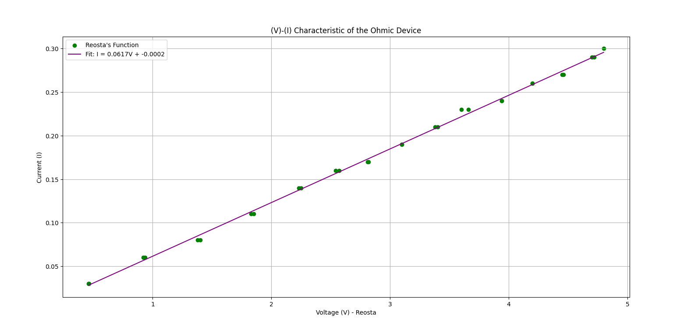

I = 0.0617V - 0.0002

This equation confirms that the resistor followed Ohm’s Lawat the range of applied voltage values. The small y-intercept value (𝑏) is likely due to minor experimental error or measurement tolerance. The slope 𝑚 represents the inverse of the resistance, and the consistency of this slope across all data points reinforces that the resistor maintained a constant resistance during the experiment.

Conclusion;

In this experiment, we successfully investigate and compare the characteristics of non-ohmic components of a circuit and ohmic components of a circuit. İn the experiment there were two distinct components: a tungsten filament bulb as non-ohmic device and a rheostat which follows the Ohm’s Law and exhibits ohmic behavior. We investigated differences in their electrical characteristics with systematic measurements and analysis of current and voltage across these elements under increasing and decreasing conditions.
The results gained from the tungsten filament bulb demonstrated non-linear relationship between current and voltage and confirmed this device as non-ohmic. Also, with the help of fitting, we have been able to visualize and understand this behavior.
On the other hand, the results from the rheostat demonstrated linear relationships between current and voltage data’s and confirmed that device follows Ohm’s Law. We successfully demonstrated fitting for this device also which help us visualize and analyze this behavior.
To summarize, the resistor exhibited a linear behavior as expected from an ohmic component and tungsten filament bulb showed a non-linear behavior due to there were some parameters that effecting voltage of the lamb as like increasing resistance of the tungsten filament as it heats up. Additionally , by plotting the respective current-voltage graphs and fitting appropriate curves, we were able to not only confirm theoretical predictions but also visually capture the distinction between ohmic and non-ohmic behavior. The resistor’s graph had indicated an excellent linear fit, while the bulb’s data was best represented by a second-degree polynomial, emphasizing its nonlinear properties.

References;
- https://canvas.instructure.com/files/292436671/download?download_frd=1

APPENDİX

Source Code
import matplotlib.pyplot as plt
import numpy as np

# Voltage and Current measurements obtained from the experiment
Vb = np.array([0.025, 0.051, 0.080, 0.120, 0.190, 0.393, 0.630, 0.850, 1.070, 1.300, 1.510, 1.750, 1.980, 2.200, 2.310, 2.210, 1.980, 1.740, 1.510, 1.280, 1.120, 0.860, 0.650, 0.430, 0.230, 0.140, 0.090, 0.050, 0.025])
Vr = np.array([0.465, 0.934, 1.400, 1.850, 2.250, 2.570, 2.820, 3.100, 3.400, 3.600, 3.940, 4.200, 4.450, 4.700, 4.800, 4.720, 4.460, 4.200, 3.940, 3.660, 3.380, 3.100, 2.810, 2.540, 2.230, 1.830, 1.380, 0.920, 0.460])
I = np.array([0.03, 0.06, 0.08, 0.11, 0.14, 0.16, 0.17, 0.19, 0.21, 0.23, 0.24, 0.26, 0.27, 0.29, 0.30, 0.29, 0.27, 0.26, 0.24, 0.23, 0.21, 0.19, 0.17, 0.16, 0.14, 0.11, 0.08, 0.06, 0.03])

# Fit functions
coeff_bulb = np.polyfit(Vb, I, 2)
poly_bulb = np.poly1d(coeff_bulb)

coeff_resistor = np.polyfit(Vr, I, 1)
poly_resistor = np.poly1d(coeff_resistor)

# X-axis for smooth plotting
x_bulb = np.linspace(min(Vb), max(Vb), 100)
x_resistor = np.linspace(min(Vr), max(Vr), 100)

# Plotting
plt.figure(figsize=(14, 6))

# Bulb Graph (Non-Ohmic)
plt.subplot(1, 2, 1)
plt.scatter(Vb, I, color='red', label="Bulb's Function")
plt.plot(x_bulb, poly_bulb(x_bulb), color='blue', label=f"Fit: I = {coeff_bulb[0]:.4f}V² + {coeff_bulb[1]:.4f}V + {coeff_bulb[2]:.4f}")
plt.xlabel("Voltage (V) - Bulb")
plt.ylabel("Current (I)")
plt.title("(V)-(I) Characteristic of the Non-Ohmic Device")
plt.grid(True)
plt.legend()

# Rheostat Graph (Ohmic)
plt.subplot(1, 2, 2)
plt.scatter(Vr, I, color='green', label="Reosta's Function")
plt.plot(x_resistor, poly_resistor(x_resistor), color='purple', label=f"Fit: I = {coeff_resistor[0]:.4f}V + {coeff_resistor[1]:.4f}")
plt.xlabel("Voltage (V) - Reosta")
plt.ylabel("Current (I)")
plt.title("(V)-(I) Characteristic of the Ohmic Device")
plt.grid(True)
plt.legend()

plt.tight_layout()
plt.show()

Experiment Sheets

